Quick Guide: How to use Seesaw
Search for Seesaw online. This will be the initial page you will see. Click on the ‘Log in’ button.
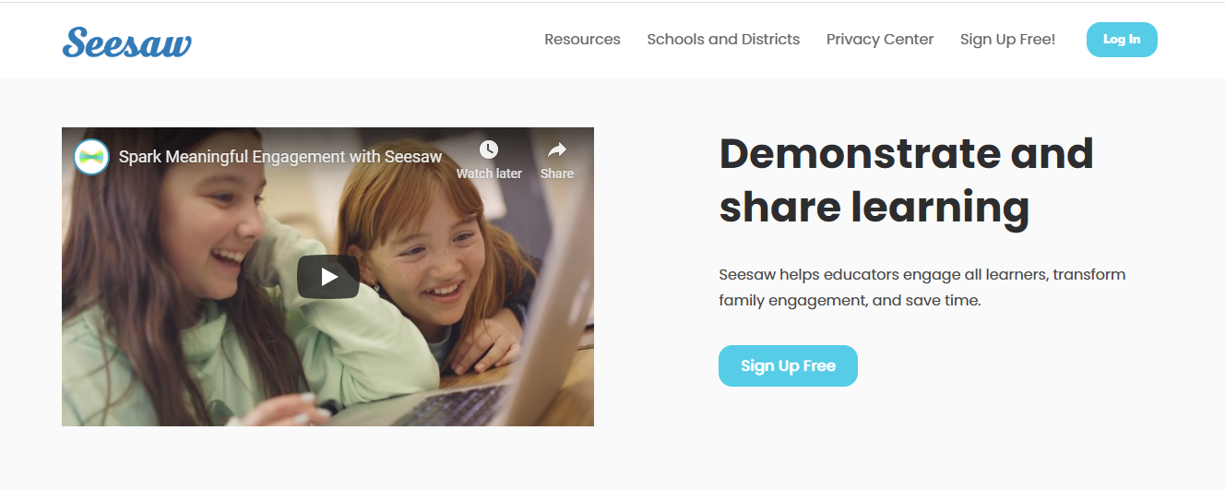
You will then be directed to this page. Alternatively if you have downloaded the Seesaw App onto a device this is the first page you will see. Click on ‘I’m a Student’.
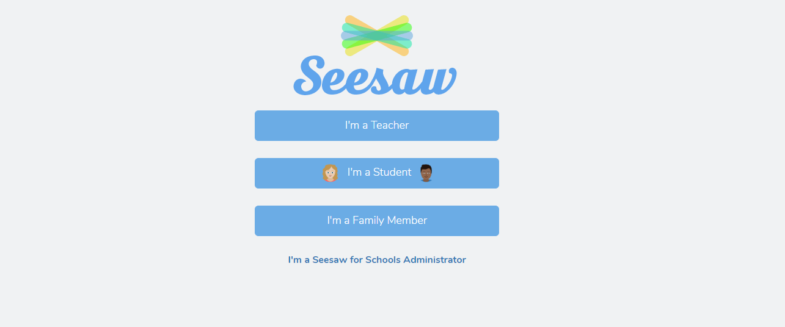
Your child will have a QR code to scan or a written TEXT CODE to insert to access their unique page.
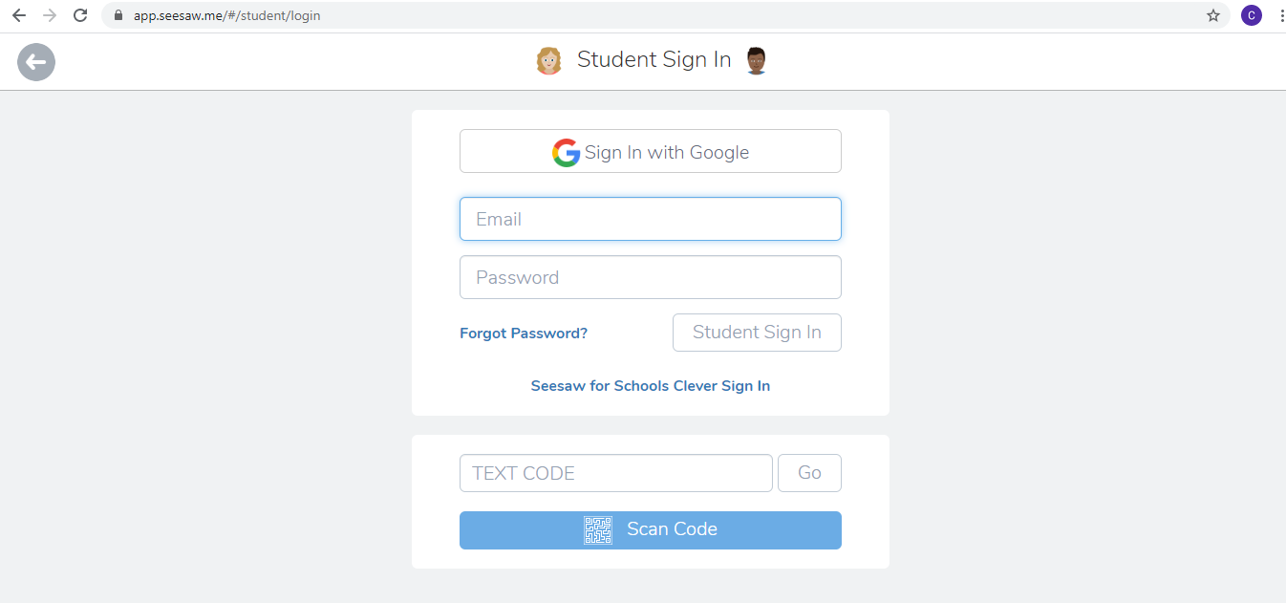
This is the image they will see when they first access their page.

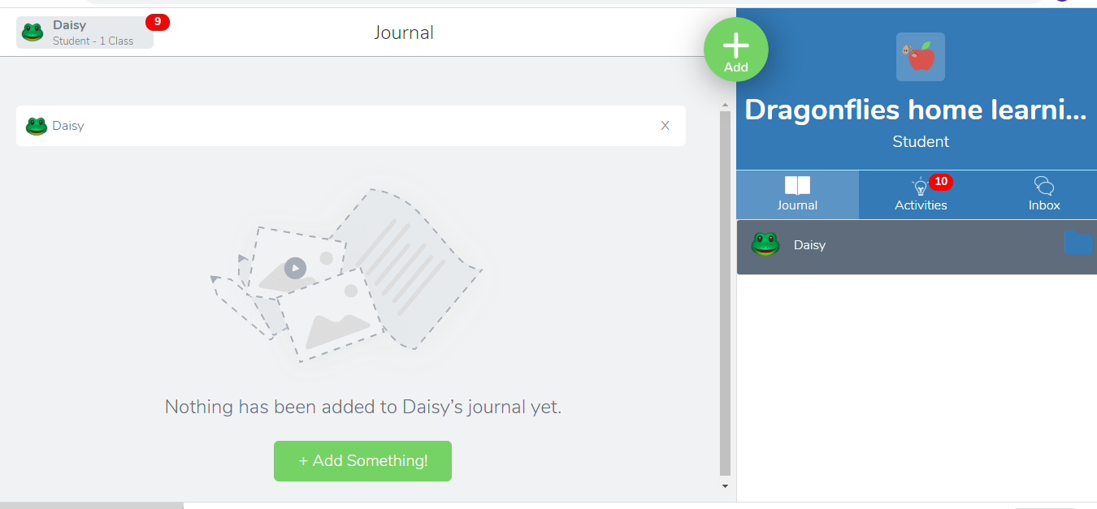

You will find Home Learning Grids and accompanying instructions in the lightbulb/Activities section.
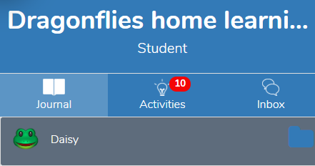

Staff will be able to send messages via the Inbox and add lots of different activities. When your child completes an activity this will appear as a log of their work in the Journal section and staff will be able to comment.

A number of activities have been set for your child which will help you all to become familiar with Seesaw.
You will need to click onto the Add Response button to respond to the task and when you have completed your response remember to click on the green tick in the corner. Activities can be completed over and over again for practice. Click on the activity on your journal and this will give you the option to respond again.

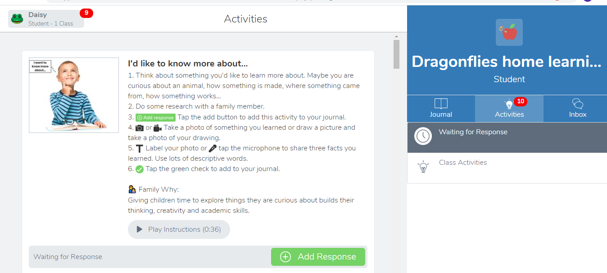

Although we have set particular activities your child can also use the Add button to add any other activities. So if they are baking, Lego making or creating encourage them to add it to their journal. Also you can add pictures or videos of other interactive activities such as: Active Learn, Giglets or Oxford Owl.
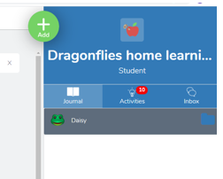
If you need any help and support please contact a member of staff who will be happy to help.

