Darran Park Primary School
Additional Learning Needs
Policy

Additional Learning Needs (ALN) Policy

In line with Local Authority (LA) guidance, at Darran Park Primary School we refer to the Additional Learning Needs Code for Wales 2021 as our authoritative operational guide to the ALN system including working practices, procedures and systems needed to implement the ALN system.

The Local Authority Principles and Expectations documents and decision-making principles are also followed.

As a school we have a personalised offer of universal and additional learning provision which meets the needs of the children in our school. Darran Park Primary School has developed inclusive classrooms and areas for children to learn in different ways. We have adopted a holistic approach to supporting pupils with emerging and identified needs and their families, utilising the skills and strengths of our staff.

All pupils have a human right to be educated alongside their peers. Darran Park Primary School is fully committed to meeting the needs of all pupils including those with additional learning needs, so far as reasonably practicable and compatible with provision of the efficient education of other pupils.

Definition of Additional Learning Needs
Most children will make good progress and not have an additional learning need (ALN) or require additional learning provision (ALP). The individual needs of these children will be met within universal provision. This can be demonstrated visually through a normal curve of distribution diagram.
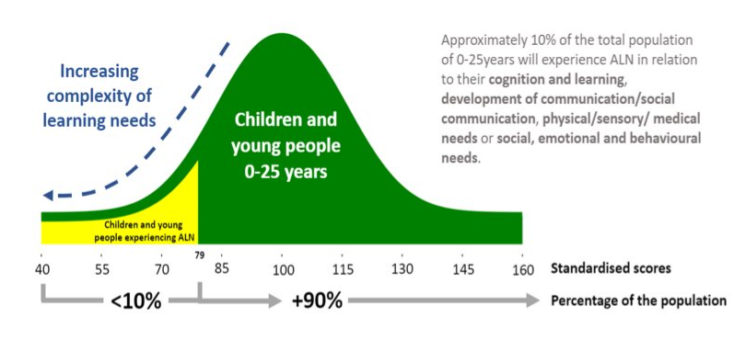

ALN responsibilities
Headteacher: Mr Christian Coole
Additional Learning Needs Co-ordinator (ALNCO): Mrs Lucia Fry
Designated Additional Learning Needs Governor: Mr Phillip Barnes

Arrangements for co-ordinating ALN provision

All staff share responsibility for identifying and supporting pupils with additional learning needs.

The ALNCo is responsible for:

- The day-to-day operation of the school’s ALN policy ensuring that the objectives and procedures set out in code are being met.
- Co-ordinating and monitoring the educational provision for children with additional learning needs.
- Working as part of the leadership team to ensure appropriate distribution of support and resources.
- Maintaining the school’s Additional Learning Needs register.
- The diagnostic testing of pupils including the delegation of these assessments to identified teaching assistants.
- Liaising with and supporting colleagues.
- Contributing to the in-service training of staff.
- Liaising with external agencies including the educational psychology service and other support agencies, medical and social services and voluntary bodies.
- Liaising with the designated Additional Learning Needs Governor and reporting to the governing body.
- Supporting parents of children with Additional Learning Needs.

The ALNCo is the bridge between the policy (i.e. in the Act, Code and regulations) and the implementation of that policy (i.e. the procedures and systems).

Class teachers and teaching assistants are responsible the delivery of the school’s universal and additional learning provision and for the identification, monitoring, assessment and intervention for pupils presenting with emerging and identified ALN.

Identification of pupils with Additional Learning Needs

At Darran Park Primary School, we are mindful of a graduated response in supporting pupils with emerging needs. Pupils in the early years are given time to develop and mature. However, staff will note any concerns they have about a child in order to develop a chronology of emerging need. This is discussed with parents and the ALNCo. Also, support can be requested from outside agencies during this time.

Staff follow the LA decision making process and will hold a Person-Centred Review with all stakeholders to determine the level of need and appropriate support. If at the end of the meeting it is felt that a child does have an additional learning need then an Individual Development Plan (IDP) will be put in place. There are two types of IDP. A school maintained IDP and a Local Authority maintained IDP. This is where the school feels it is not possible to secure and provide the additional learning provision required and therefore the IDP will be maintained by the Local Authority. If the agreement is that the child does not have an ALN then their needs will be met through universal provision.

At all stages, the principles of person-centred practises are adhered to. Pupils who have emerging and identified additional learning needs have a One Page Profile and support plan. The support plan includes targets for children accessing universal provision to monitor their progress. These are reviewed twice a year and meetings are held with parents.

For pupils with identified learning needs and where a school Individual Development Plan is in place a progress review will take place at the same time as the support plan reviews as well as an annual review of the objectives.

Pupils who hold a statement will continue to have annual reviews and will move over to an IDP.

Children who are Looked After (CLA)

A register of children with social services involvement is kept by the Designated Safeguarding Officer. A CLA pupil will have a Personal Education Plan (PEP) which is put in place as required before a CLA review. CLA pupils identified with additional learning needs will have a specific Individual Development Plan.

Access for all pupils for the curriculum and well-being

All pupils are entitled to fully access the Curriculum for Wales. Staff are responsible for universal and additional learning provision and so learning opportunities will be differentiated accordingly.

All children will develop their personal and social skills, an awareness of personal wellbeing and an understanding of cultural diversity. Through activities planned to their ability and needs, and with a growth mindset approach, pupils will develop a positive self-image, feelings of self-worth and self-esteem.

Teachers will plan activities that take account of the children's developmental needs and the skills that they need to grow to become confident learners. Teachers will be mindful of any barriers that the children have to access play, to learning and participation caused by physical, sensory, communication or learning difficulties. Our children will develop an understanding that others have differing needs and abilities. All children, regardless of race, gender, disability or ALN will be supported in becoming confident, competent and independent thinkers and learners.

At Darran Park Primary School we have adopted the Thrive and ELSA Approach and use this as a form of targeted support in relation to pupils social and emotional development. Pupils are identified and supported as needed, this forms part of our universal provision offer. The licensed practitioner will draw up an action plan which includes targets, strategies and activities that can be delivered with individual pupils, small groups or as a class approach.

Dispute resolution

In the first instance, any complaint about the additional provision for a child in the school should be made to the class teacher. Should the matter not be resolved at this stage, the ALNCo will deal with the complaint.

Any unsolved complaints will ultimately be referred to the Headteacher for consideration, who will then consult with any other relevant member of staff and outside agency. It is the responsibility of the Headteacher to inform governors of any such complaint and the parent will then be given a response. School will follow the ALN legislative framework, created by the Additional Learning Needs and Education Tribunal (Wales) Act 2018.

Partnership working
Parents/Carers are partners in their child’s education and are kept fully informed. They will be contacted directly should there be any change in their child’s progress, behaviour or educational provision within school. In line with the Additional Learning Needs Code for Wales 2021 we value parental partnership and engagement. All meetings and reviews are held following a person-centred approach, using a person-centred toolkit.

Use of support services

At Darran Park Primary School we work closely with the Additional Learning Needs Support Service (ALNSS) and the Educational Psychology Service (EPS) in order to secure bespoke support and advice to meet pupils’ additional learning needs.

Links with other schools and settings

We value collaborative working with our cluster schools. Half termly meetings are held with the Ferndale Cluster schools to share good practice. There is also regular contact with the ALNCO at Ferndale Community School and summer term handover meetings to exchange information.

Transition work takes place throughout the year for our Year 6 pupils.

New starters in our nursery class are offered link up opportunities and a home visit before their child starts at school.

Date approved: 8/3/23

Date to be reviewed: Spring Term 2024

Signed:______________________________ ALNCo

Signed: ______________________________ Headteacher

Signed: _______________________________Chair of Governors

Signed:________________________________Link Governor

Date: __________________________

