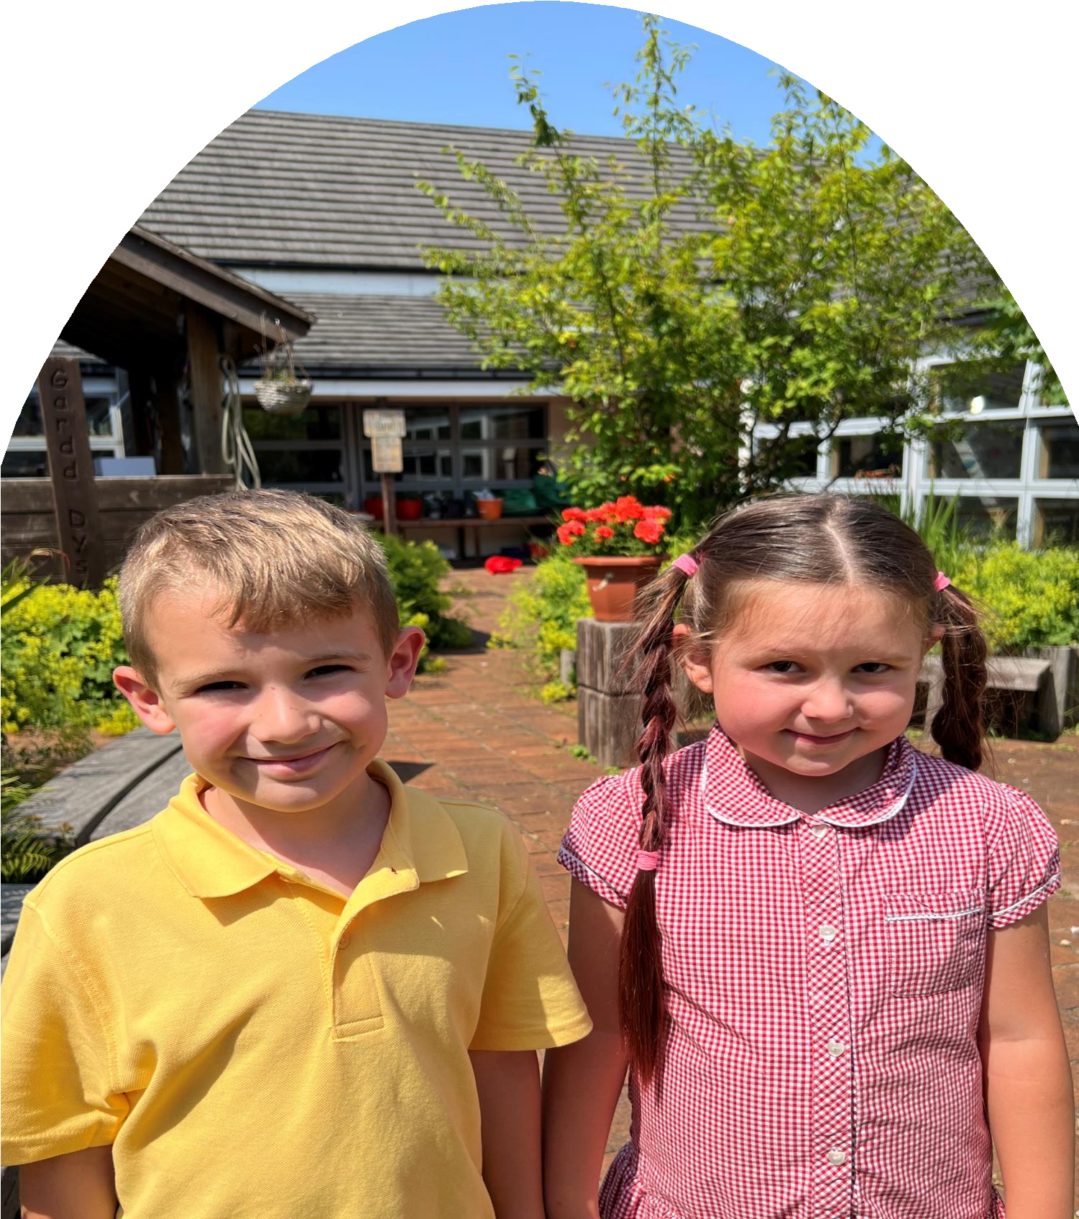
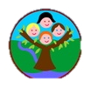

Curriculum Policy

Darran Park Primary School
Learning, Enjoying and Achieving Together

Curriculum Policy

Darran Park Primary School

Policy Adopted

Headteacher | Chair of Governors
Christian Coole | Roy Maddox
Date:21/6/23 | Date:21/6/23

Policy Reviewed

Date of review | Reviewer | Details
Summer Term 2025

Contents

Curriculum definition
Vision
Curriculum aims
Curriculum structure and design
-The four purposes
- Integral skills
- Areas of Learning and Experience (AoLE's)
- Statements of what matter
- Description of learning
- Progression
- The role of disciplines in our curriculum - Mandatory curriculum elements
- Cross-cutting themes
- Learners’ choice
- A curriculum accessible to all
Learning and teaching
Assessment
- The purpose and role of assessment within our curriculum
- The role of different participants in our assessment process
Curriculum Summary
Curriculum review, evaluation and revision

Curriculum definition
Our school curriculum is defined as everything our learners experience in pursuit of the four purposes.
It is not just what we teach but is also how we teach it and importantly, why we teach it.

Introduction
Our approach to the introduction of the new Curriculum for Wales has been planned for with the inclusion of all our stakeholders. Together, as a team, we aim to create a curriculum that is bespoke to Darran Park Primary School and reflects the context of our pupils.

We will provide a curriculum that is unique to our school and one that provides aspiration to every pupil, putting pupils at the heart of everything we do, providing them with a voice and valuing them as individuals. Through engaging, meaningful, authentic learning opportunities pupils experience a thematic inquiry approach to learning that helps them to make connections and learn through memorable experiences that are inclusive for all.

Vision
At Darran Park Primary School our vision is to develop ambitious, capable learners who are ready to learn throughout their lives. We strive to create a safe, secure and stimulating environment that promotes curiosity and nurtures the development of growing minds; where all pupils are happy and enjoy learning. We nurture ethical informed citizens who are ready to be citizens of Wales and the world. We will foster a strong sense of community and belonging where children
develop mutual respect for themselves, each other and the environment.
We will support our learners to be enterprising confident individuals and strive to provide all learners with the tools and strategies to succeed in work and life. Everyone will be encouraged to try their best and achieve their own personal full potential. High quality learning experiences will be provided for all children, and we will celebrate successes, innovation, and aspiration.
At Darran Park Primary School our vision is to nurture healthy confident individuals who are ready
to lead fulfilling lives as valued members of society. Through providing high quality
learning experiences, our school family will ensure learners develop a positive attitude to
learning and never give up if they find something difficult or challenging. This will ensure each member
of the Darran Park family can develop an individual and flourish as 21st century learners.

Curriculum aims
To make our vision a reality for our learners, our curriculum will:

- enable our learners to realise the four purposes and equip them for ongoing learning, work and life;
- build high expectations and enable all learners to achieve their full potential;
- offer a broad and balanced education, which enables our learners to make links between the different areas of learning and experience (Areas) and apply their learning to new situations and to more complex issues;
- support progression along a continuum of learning;
- support our learners’ health and well-being, including their mental health and well-being;
- support our learners’ development of knowledge that is the foundation of being an informed
citizen;
- recognise our learners’ identity, language(s), ability and background and the different support they
may need given their particular circumstances;
- reflect the diversity of perspectives, values and identities which shape our locality and Wales and
develop understanding of the wider world;

  - enable our learners to make sense of growing up in contemporary Wales and of issues which will
be important in the future, including well-being, sustainable development and citizenship;
  - support our learners to critically engage with a range of information and to assess its value and
validity;
  - enable our learners to develop an understanding of their rights and the rights of others.
  - be built in co-construction with our stakeholders (learners, families, the wider community, our
cluster colleagues

Curriculum structure and design
The four purposes

The four purposes are the aspiration for all learners in Wales. Our curriculum is designed so that all
our learners will be supported to develop as:

ambitious, capable learners who:
  - set themselves high standards and seek and enjoy challenge
  - are building up a body of knowledge and have the skills to connect and apply that knowledge in
different contexts
  - are questioning and enjoy solving problems
  - can communicate effectively in different forms and settings, using both Welsh and English
  - can explain the ideas and concepts they are learning about
  - can use number effectively in different contexts
  - understand how to interpret data and apply mathematical concepts
  - use digital technologies creatively to communicate, find and analyse information
  - undertake research and evaluate critically what they find

and are ready to learn throughout their lives

enterprising, creative contributors who:
  - connect and apply their knowledge and skills to create ideas and products
  - think creatively to reframe and solve problems
  - identify and grasp opportunities
  - take measured risks
  - lead and play different roles in teams effectively and responsibly
  - express ideas and emotions through different media
  - give of their energy and skills so that other people will benefit

and are ready to play a full part in life and work

ethical, informed citizens who:
  - find, evaluate and use evidence in forming views
  - engage with contemporary issues based upon their knowledge and values
  - understand and exercise their human and democratic responsibilities and rights
  - understand and consider the impact of their actions when making choices and acting
  - are knowledgeable about their culture, community, society and the world, now and in the past
  - respect the needs and rights of others, as a member of a diverse society
  - show their commitment to the sustainability of the planet

and are ready to be citizens of Wales and the world

healthy, confident individuals who:
- have secure values and are establishing their spiritual and ethical beliefs
- are building their mental and emotional well-being by developing confidence, resilience and
empathy
- apply knowledge about the impact of diet and exercise on physical and mental health in their daily
lives
- know how to find the information and support to keep safe and well
- take part in physical activity
- take measured decisions about lifestyle and manage risk
- have the confidence to participate in performance
- form positive relationships based upon trust and mutual respect
- face and overcome challenge
- have the skills and knowledge to manage everyday life as independently as they can

and are ready to lead fulfilling lives as valued members of society.

The four purposes are the starting point for all decisions around curriculum design our curriculum is
planned in a way that supports our learners to make progress toward them.

Integral skills

The four purposes are also underpinned by integral skills which will be developed through a wide
range of teaching and learning within our curriculum.

Creativity and innovation
Our curriculum will be designed in a way that develops our learners’ creativity and innovation by
providing the space for and the opportunities that support them to:

- be curious and inquisitive, and to generate ideas;
- link and connect disparate experiences, knowledge and skills, and see, explore and justify
alternative solutions;
- be able to identify opportunities and communicate their strategies.

This will support our learners to create different types of value.

Critical thinking and problem-solving
Our curriculum will be designed in a way that develops our learners’ critical thinking and problem
solving by providing the space for and opportunities that support them to:

- ask meaningful questions, and to evaluate information, evidence and situations;
- analyse and justify possible solutions, recognising potential issues and problems;
- become objective in their decision-making, identifying and developing arguments;
- be able to propose solutions which generate different types of value.

Personal effectiveness
Our curriculum will be designed in a way that develops our learners’ personal effectiveness by
providing the space for and opportunities that support them to:

- develop emotional intelligence and awareness helping them to become confident and independent;
- lead debate and discussions, helping them to become aware of the social, cultural, ethical and legal
implications of their arguments;

  - evaluate their learning and mistakes, helping them to identify areas for development;
  - become responsible and reliable;
  - be able to identify and recognise different types of value and then use that value.

Planning and organising
Our curriculum will be designed in a way that develops our learners’ planning and organising by
providing the space for and opportunities that support them to:

  - set goals, make decisions and monitor interim results (where developmentally appropriate);
  - reflect and adapt, as well as manage time, people and resources.
  - check for accuracy and be able create different types of value.
  - develop an appreciation of sustainable development and the challenges facing humanity
  - develop awareness of emerging technological advances
  - confidently meet the demands of working in uncertain situations, as changing local, national and
global contexts result in new challenges and opportunities for success
  - generate creative ideas and to critically evaluate alternatives
  - build their resilience and develop strategies which will help them manage their well-being – they should be encountering experiences where they can respond positively in the face of challenge, uncertainty or failure
  - learn to work effectively with others, valuing the different contributions they and others make – they should also begin to recognise the limitations of their own work and those of others as they build an understanding of how different people play different roles within a team.

Areas of Learning and Experience (AoLE's)

Our school curriculum is designed in a way that ensures learning and teaching that encompasses all
six Areas of Learning and Experiences (Areas)

  - Expressive arts
  - Health and well-being
  - Humanities
  - Languages, literacy and communication
  - Mathematics and numeracy
  - Science and technology

All Areas have equal status within our curriculum.

Statements of what matter

Our school curriculum provides opportunities for our learners to engage with and develop their
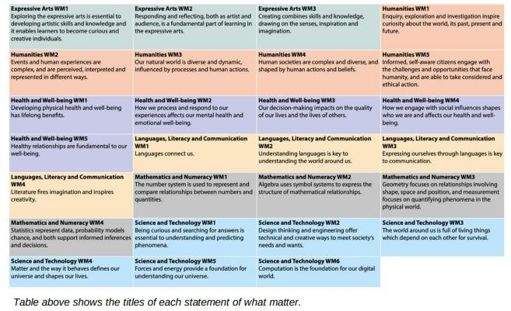
understanding of the key concepts within all the statements of what matter.
Our curriculum uses the statements of what matter to guide the selection of all curriculum content.
Specifically, they are used to:

  - select the range of experiences, knowledge and skills that enable our learners to make sense of
the ‘big ideas’ and key principles within each statement
  - support our learners’ progression within the ‘big ideas’ and key principles and their ability to be able to develop an increasingly sophisticated understanding and application of the statements of what matter
  - allow learners to explore topics and ideas through different lenses – the same concept or idea will
be explored through different statements of what matter
  - help our learners to make sense of a range of experiences, knowledge and skills within each Area by ensuring that content helps learners to develop a coherent understanding of a range of information.

Descriptions of learning
At our school, we have chosen to use the descriptions of learning as a planning tool to support selection of a wide range of knowledge, skills and experiences within our curriculum. Our curriculum also uses the descriptions of learning to inform planning for a range of contexts for learning across a progression step to create depth and breadth across our curriculum. Our curriculum does not use the descriptions of learning to create stand-alone tasks, activities, assessment tasks or interim reports to make judgements about our learners’ outcomes at a particular point on the continuum.

Progression
Progression in learning is a process of increasing depth, sophistication, engagement and learner control, rather than of covering a body of content. Progression is not linear and different learners are likely to progress in markedly different ways. Progression is at the heart of our curriculum design.
When selecting the content of our curriculum and assessment, we use the principles of progression for each Area to inform our approach to progression. Progression in Mathematics and Numeracy also involves the development of five proficiencies which are connected and interdependent.
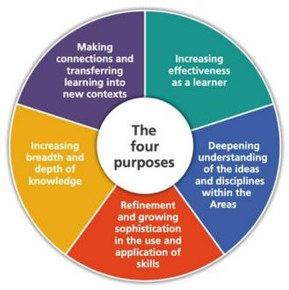

Link to supporting guidance: Shared understanding of progression.pdf (gov.wales)

Our Ferndale cluster schools meet regularly in AoLE teams to explore, discuss and develop an
understanding of:

- joint expectations for how learners should progress
- how knowledge, skills and experiences should contribute to this – drawing on the principles of
progression, statements of what matters, and descriptions of learning.
- how to ensure coherent progression for learners throughout their learning journey and in
particular at points of transition (e.g., from primary to secondary school)
- their relative expectations for progression, to ensure coherence and equity between schools, and
sufficient pace and challenge in their approach with each AoLE team creating progression maps.

The role of disciplines in our curriculum

As our learners’ progress through our curriculum, they will have greater opportunities to engage with the different disciplines within each Area and to specialise in them as they reach the later progression steps.

Our curriculum overview
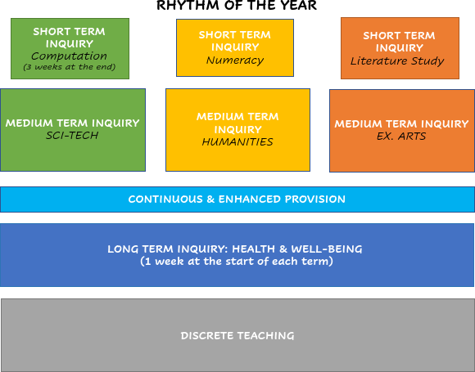

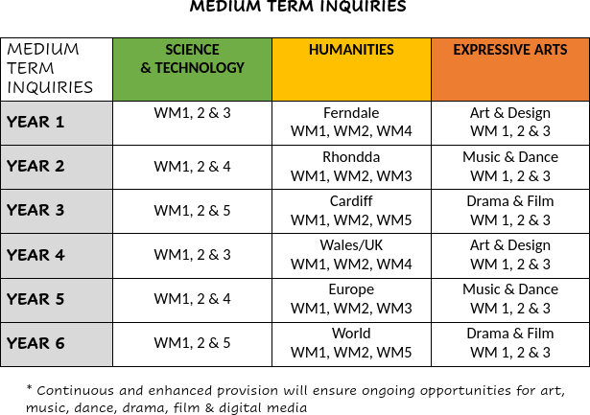

Mandatory curriculum elements

Our curriculum will include:
  - Welsh
  - English from 7 years old
  - Relationships and Sexuality Education (including the detail of the Relationships and Sexuality
Code)

  - Religion Values and Ethics (RVE)
  - The cross-curricular skills (literacy, numeracy and digital competence)

Relationships and sexuality education

Relationships and sexuality education (RSE) within our curriculum is planned using the RSE Code
and is designed in a way that is developmentally appropriate, inclusive and pluralistic. See our RSE policy.

Religion, Values and Ethics (RVE)

RVE is a mandatory subject within the Humanities AoLE

Religion, Values and Ethics (RVE) is mandatory for all learners aged 3 – 16 and sits within the Humanities Area of Learning and Experience. Teaching and learning in RVE reflects that the religious traditions in Wales are in the main Christian while taking account of the teaching and practices of the other principal religions represented in Wales. It also reflects the fact that a range of non-religious philosophical convictions are held in Wales. RVE is planned to meet the mandatory requirements of the Humanities AoLE, and to have regard to both the statutory RVE guidance within the Humanities Area, and the RCT Locally Agreed Syllabus. There is no right to withdraw from RVE.

Cross-curricular skills
We believe that the mandatory cross-curricular skills of literacy, numeracy and digital competence are essential for learners to be able to access knowledge. They enable learners to access the breadth of our curriculum, equipping them with the lifelong skills torealise the four purposes.
These are skills that can be transferred to the world of work, enabling our learners to adapt and
thrive in the modern world.

Our curriculum is designed in a way that enables learners to develop competence and capability
in the cross-curricular skills and extend and apply them across all Areas.

Across our curriculum, learners will be given a range of opportunities to:
  - develop listening, reading, speaking and writing skills
  - be able to use numbers and solve problems in real-life situations
  - be confident users of a range of technologies to help them function and communicate
effectively and make sense of the world

Cross-cutting themes

Cross-cutting themes for designing your curriculum

Relationships and sexuality education (RSE)
Our curriculum is designed in a way that identifies and makes authentic and meaningful links
between learning within a particular Area and learning within the RSE Code.

Human Rights
We believe that learning about human rights empowers learners as rights -holders. This enables our learners to critically examine their own attitudes and behaviours and to develop skills to be ethically-informed citizens of Wales and the world, who can be advocates for their rights and the rights of others.

Our curriculum incorporates opportunities for our learners to:

  - learn about human rights by developing their understanding of what human rights are and where those rights have come from including. This includes developing their understanding of the UNCRC and UNCRPD.
  - learn through human rights which supports our learners to develop values, attitudes and
behaviours that reflect human rights.
  - learn for human rights, which motivates them to social action, empowerment of active
citizenship and to advance respect for the rights for all.

Careers and work-related experiences (CWRE)
We believe that learning about CWRE is fundamental to developing skills for work and life. Our curriculum incorporates opportunities for CWRE that inspires our learners to:
  - develop an understanding of the purpose of work in life, both for themselves and for society as
a whole
  - become increasingly aware of the range of opportunities available to them, broadening their
horizons
  - develop the attitudes and behaviours required to overcome barriers to employability, career
management and lifelong learning
  - appreciate the increasing range of opportunities in the workplace where an ability to
communicate in Welsh is important
  - explore opportunities through a variety of meaningful experiences in learning, work and
entrepreneurship
  - develop resilience and the ability to be adaptable in response to the challenges, choices and
responsibilities of work and life

Local, national and international contexts
Local, national and international contexts provide key perspectives for our learners and are important in supporting them to realise the four purposes.

Our curriculum incorporates opportunities for learners to:

  - develop learning through a range of places and events of significance
  - make links with the local community and organisations
  - learn about the contributions and experiences of different individuals that shape each context

  - learn about cultural diversity, values, histories and traditions that shape each context
  - understand different identities, histories, cultures, perspectives and values that shape
communities and societies
  - recognise and engage with factors, influences and impacts (including economic, social and
environmental impacts) locally, nationally and internationally
  - develop an authentic sense of cynefin*, building knowledge of different cultures and histories, allowing them to develop a strong sense of individual identity and understanding how this is connected to and shaped by wider influences
  - draw on the stories and distinctiveness of our school’s local surroundings
  - understand their role as citizens and the structures of government which affect them in each
context
  - explore, critically analyse and respond to contemporary issues and challenges affecting their
lives and the lives of others through each context
  - understand sustainable development, the challenges the environment and society face and how
they can engage with and make a difference on these issues supporting sustainable citizenship
  - understand contemporary Wales, providing opportunities to reflect, understand and analyse
contemporary society and their engagement with it
  - recognise Wales’ diverse linguistic heritage and culture, and its connections with the rest of the
world
  - recognise how our languages unlock knowledge about our literature, geography, history and
their links beyond Wales
  - recognise the links between local, national and international contexts, understanding how they constantly influence each other
  - use critical analysis in each context, recognising both positive and challenging aspects within
each

*Cynefin - The place where we feel we belong, where the people and landscape around us are familiar, and the sights and sounds are reassuringly recognisable. Though often translated as 'habitat' Cynefin is not just a place in a physical or geographical sense; it is the historic, cultural and social place which has shaped and continues to shape the community which inhabits it.

Learning and teaching
Our vision for learning and teaching at Darran Park Primary is to:

- Create a happy school environment that fully engages and stimulates all pupils.
- Create a curriculum that is broad and balanced and relevant to the changing demands of our
local community and broader society
- Deliver a “Four Purpose” driven curriculum
- Develop each individual to their potential through offering a wide range of high-quality skills
and knowledge-based experiences
- Encourage a love of learning and high levels of confidence through a growth mindset approach
- Seek and respond to Pupil Voice in all aspects of school life.
- Ensure our curriculum includes a variety of teaching and learning styles taking into account gender, race, language, disability and socio-cultural backgrounds
- Promote equality of opportunity and respect for everyone, irrespective of belief, race, sexual identity, age and gender.
- Develop effective thinking, independent learning and the ability to solve problems creatively.
- Use every opportunity to develop the skills of Numeracy, Literacy and Digital Competency
enabling each child to experience achievement at all levels.

- Enable pupils to be given progressive responsibility for organising their
learning and management of time.
- Develop an appreciation of the heritage and history of Wales, including Black achievement,
through authentic contexts, as well as learning the Welsh language.
- Enhance self-worth and the ability to value each person’s own worth through a caring, secure environment. This will develop sensibility to others, self-discipline, high self-esteem and acceptable behaviour.
- Develop imagination and creativity by offering a wide range of authentic learning experiences.
- Develop the natural curiosity that children exhibit about themselves and their world and use
their curiosity to foster positive attitudes to learning.

Assessment

The purpose and role of assessment within our curriculum

Assessment is an integral part of teaching and learning and plays a fundamental role in enabling our learners to make progress. For assessment to be effective, we recognise that partnerships between our practitioners, our learners and parents and carers are important.

Progression in learning is a process of increasing depth, sophistication, engagement and learner control, rather than of covering a body of content. Progression is not linear and different learners are likely to progress in markedly different ways. Assessment planning and practice, built into the curriculum and classroom practice, should recognise this and allow for a variety of diversions, stops and variations in pace in a learner’s journey. We will assess all learners across the 3 to 16 continuum based on the progression articulated in our curriculum, against planned learning intentions.

Link to Welsh Government supporting guidance: Assessing learner progress.pdf (gov.wales)

The role of different participants in our assessment process

Leaders
Leaders at our school will establish a strong learning culture that supports and challenges our
practitioners to enable them to make appropriate progress. This is achieved by:

- creating a clear vision for curriculum that supports our learners’ realisation of the four
purposes and supports individual learner progression;
- creating an environment that develops the necessary knowledge and skills to
promote learner wellbeing;
- creating an environment based on mutual trust and respect, rather than one
focused on compliance and reporting;
- enabling our practitioners to develop the knowledge and skills necessary to carry out their
role in assessment effectively;
- ensuring the design, adoption, review and revision of our curriculum that
affords opportunities for our practitioners to plan purposeful learning that addresses the needs of
each of our learners;

- developing and embedding processes and structures that enable our practitioners to develop
a shared understanding of progression;
- ensuring there is a clear picture of learner progression within our school that is understood by all our practitioners, a process that embeds regular ongoing professional dialogue on progression into our systems to support selfreflection and inform improvement;
- ensuring there is a clear understanding of learner progression across our cluster of schools
that feeds into discussions on learner progression within each school or setting
- considering how additional challenge and support for our learners can be best
provided, including working with other partners
- encouraging engagement between all participants in the learning and teaching process in
order to develop effective partnerships
- ensuring that the statutory requirements have been met and that due regard has been paid to this guidance for assessment, and that practitioners are taking account of this in planning, learning and teaching and within daily practice.​

Practitioners
Practitioners at our school will plan for and provide effective learning experiences that
are appropriate to the age and development of our learners. They support and challenge learners effectively to ensure individuals make progress from their own starting points. This is achieved by:

- being clear about the intended learning, and planning engaging learning experiences
accordingly;
- supporting the promotion of learner well-being through assessment practice;
- sharing intended learning appropriately with learners;
- evaluating learning, including through observation, questioning and discussion;
- using the information gained from ongoing assessment to reflect on their own practice to
inform next steps in teaching and planning for learning;
- providing relevant and focused feedback that actively engages learners, encourages them to
take responsibility for their learning, and moves their learning forward;
- encouraging learners to reflect on their progress and, where appropriate, to consider how they have developed, what learning processes they have undertaken and what they have achieved;
- providing opportunities for learners to engage in assessing their own work and that of their
peers, and supporting them to develop the relevant skills to do this effectively;
- developing learners’ skills in making effective use of a range of feedback to move their
learning forward;
- involving parents and carers in learner development and progression, with the learner’s involvement in this dialogue increasing over time;
- engaging in dialogue with leaders and fellow practitioners to ensure we have a clear picture of
the progress being made within our school;
- identifying any additional challenge or support learners may require, engaging with
external partners where necessary.

Learners
Our learners will participate in and contribute to the learning process in a way that is appropriate to their age and stage of development. This will help them develop knowledge, skills and understanding, and to apply them in different contexts. As they make progress with increasing independence, our learners will be supported and encouraged to:

- understand where they are in their learning and where they need to go next;
- develop an understanding of how they will get there;
- respond actively to feedback on their learning, and develop positive attitudes towards receiving,
responding to and acting upon feedback in their learning;
- review their progression in learning and articulate this both individually and with others;
- reflect on their learning journey and develop responsibility for their own learning over time

Parents and carers
Parents and carers have an important role to play in assessment and we will engage with them so that they can support their child’s progress in an appropriate way. We will encourage and enable parents and carers to:

- engage regularly with our school and our practitioners in order to understand and support their
child’s progression in learning;
- share relevant knowledge and understanding with us which will support their child’s learning and
progression;
- respond actively to information provided about their child’s learning and, in collaboration with us,
plan ways of supporting that learning within and outside of school.

External partners
We will engage external partners to:
- help our practitioners assess and identify the needs of learners who may require additional support and then help them through the provision of advice and support. This includes specialisteducational support and support from other agencies such as health
- provide information about learning progression that has taken place for our learners who
may spend some of their time in other contexts.

Supporting each of our learners on an ongoing, day-to-day basis
To support our learners on an individual and ongoing, day-to-day basis, assessment is embedded into
everyday classroom practice in a way that supports and is indistinguishable from learning. Our assessment practices will identify each individual learner’s strengths, achievements, areas for improvement and, where relevant, barriers to learning. This understanding will be used by our practitioners, in discussion with our learners, to ascertain the next steps required to move their learning forward, including any additional challenge and support required.

Identifying, capturing and reflecting on each learner’s progress over time
Our practitioners will identify the progress being made by our learners, and record this,
where appropriate, to understand each learner’s journey over different periods of time and in a variety of ways. This includes developing an understanding of how a learner has learned, as well as what they have learned and are able to demonstrate. Reflecting on a learner’s progress over time will enable our practitioners to provide feedback and plan their future learning, including any interventions, additional support or challenge that may be required. This feedback will include both immediate next steps and longer-term objectives and goals that the learner should work towards to help keep them moving forward in their learning. This information will also be used as a basis
for communicating and engaging with our parents and carers.

Approaches that support us in identifying, capturing and reflecting on each of our learner’s
progress over time

Supporting learner progression: assessment guidance

Understanding group progress in order to reflect on our practice
Assessment enables our practitioners and leaders to understand to what extent and in what ways different groups of learners are making appropriate progress. This understanding contributes to our processes of self-evaluation and continuous improvement.

Communicating with parents and carers
When communicating and engaging with parents and carers, we share information about:

  - the progress their child is making
  - their future progression needs
  - how future progression needs can be supported at home
  - their general well-being in school

We share learner information with parents and carers termly – in October, February and July. We provide a summary of individual learner information annually.
Our learners are provided with opportunities to contribute to the communication process
with their parents and carers.

On-entry assessments
At any point a learner enters our school, [including when they enter compulsory school-
age education {primary only}], we will assess the capabilities, skills, knowledge and aptitudes of learners against our curriculum to determine the next steps in their progression and the learning and teaching needed to make that progress.

Transition
In accordance with the 2022 Transition Regulations our transition plan covers the
following matters:
  - proposals for managing and coordinating the transition of learners from feeder primary
schools to the secondary school
  - proposals for how continuity of learning will be achieved through curriculum design and
planning for learning and teaching for learners in Year 6 transitioning to Year 7
  - proposals for how each individual learner’s progression will be supported as they transition
from primary school to secondary school
  - proposals for how the learning needs and the well-being of each individual learner will
be supported as they transition from primary school to secondary school
  - proposals for reviewing and monitoring the impact of the transition plan in respect of how it
has helped:
o achieve continuity of learning
o support individual learner progression

Curriculum Summary
In line with the mandatory requirement for schools to publish a summary of their curriculum, a
copy of our curriculum summary can be found here. - Curriculum Summary

Curriculum review, evaluation and revision

The review process It is the responsibility of the governing body and headteacher to keep the curriculum and assessment arrangements under review, revising them if they no longer comply with our curriculum policy.

